**A picture containing clipart

Description generated with very high confidence**

Using Conditions in Manifest

DevOps Certification Training

[**support@intellipaat.com**](mailto:support@intellipaat.com)

**+91-7022374614**

**US: 1-800-216-8930(Toll Free)**

**USING CONDITIONS IN MANIFESTS**

**ONLYIF**

**Steps for Puppet Master**

**Step 1:** Change the directory to **/etc/puppet/code/environments/production/manifests**

$ cd /etc/puppet/code/environments/production/manifests

$ sudo nano site.pp

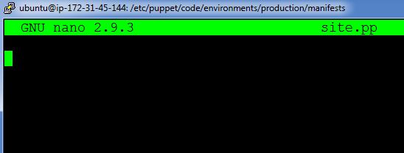

**Step 2:** Enter the following text:

node default{

exec{'Conditions':

command=> '/bin/echo "Apache is installed" > /tmp/software.txt',

onlyif=> '/bin/which apache2',

}

}

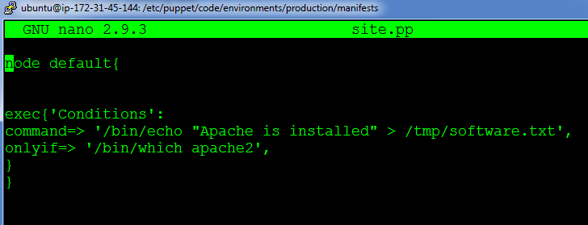

**On Puppet Agent**

**Step 1:** Execute the following command:

$ sudo puppet agent --test

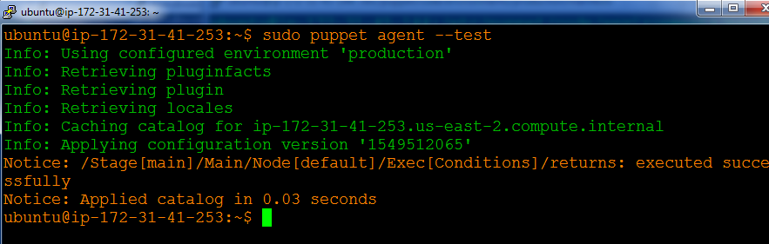

**Step 2:** Verify the file by going to /tmp/software.txt

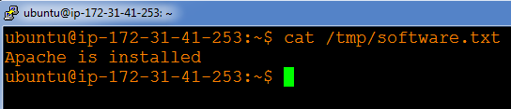

**UNLESS**

**Steps for Puppet Master**

**Step 1:** Change the directory to **/etc/puppet/code/environments/production/manifests**

$ cd /etc/puppet/code/environments/production/manifests

$ sudo nano site.pp



**Step 2:** Enter the following text:

node default{

exec{'Conditions':

command=> '/bin/echo "php is not installed" > /tmp/software.txt',

unless=> '/bin/which php,

}

}

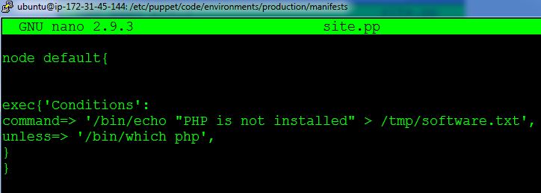

**Steps for Puppet Agent**

**Step 1:** Execute the following command:

$ sudo puppet agent --test

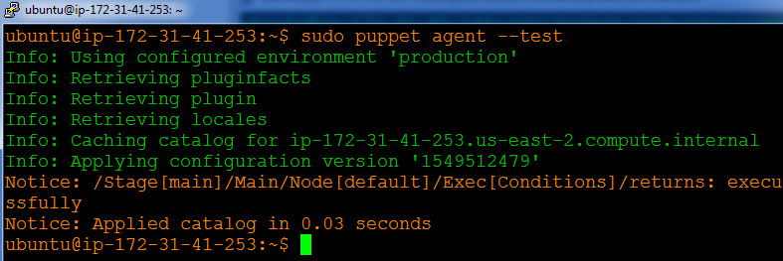

**Step 2:** Verify the file by going to /tmp/software.txt

